Custom soldering station

|  |  |
| --- | --- |
| Author | Runar Jans |

Content

1 Introduction 1

2 Material and methods 2

3 Results 2  
 1. Startup menu  
 2. Temperature adjustment  
 3. Soldering  
 4. Power-off and storage  
 5. Pictures of the soldering station

4 Discussion 2

5 Reference list 2

# Introduction

The subject of this application note is a soldering station that features a custom-designed PCB (printed circuit board) and case. This case is 3D-designed 3D-printed. The soldering station has the ability to vary the output temperature at the tip of the iron and display this temperature on a 7-segment display.   
The primary function of the soldering station is heating up and melting solder wire to connect components with wires or circuit boards.

This build is part of the education program in Hogeschool PXL ,for the first year of ICT-Elektronica. The starting point was the Elektor magazine, which featured an example soldering station. This magazine provided information on the parts used and included several schematics as well.

The Application Note discusses the materials and methods used for the project. It also provides an overview of the end result with pictures included. The difficulties faced during the project and a reflection on the build are also documented. Finally, the note includes a reference list.

# Material and methods

PCB-design was created using the Altium Designer software.  
The schematics used for this project are very similar to the ones used by Elektor.  
  
The designing process started by checking which components are available. Unavailable parts were replaced by alternatives. Footprints and schematics of components could be found online or had to be custom drawn. After designing the layout of the PCB, the circuit board could be made by JLCPCB. This is a company specialised in producing circuit boards. JLCPCB also made a stencil specifically for applying solder paste on this circuit board. SMD components were then placed on the solder paste at their designated locations. The assembled PCB was then placed in a PCB oven for reflow soldering. This process hardens the paste and ensures that the components won't come loose under normal circumstances. Calibration and testing of the device were conducted to ensure proper functionality.

Fusion 360 was the software used to make the 3D-printed housing.   
This software is part of the Autodesk package and is free for students.   
  
3D-printers use 3 dimensional drawings to make all kinds of objects out of certain materials.   
The material gets melted and a figure is formed layer by layer.

PLA (Polylactic acid) is the type of filament used for this housing.   
The 3D printer used for this project belongs to a friend.

Figure 1 is an overview of the components used by Elektor.

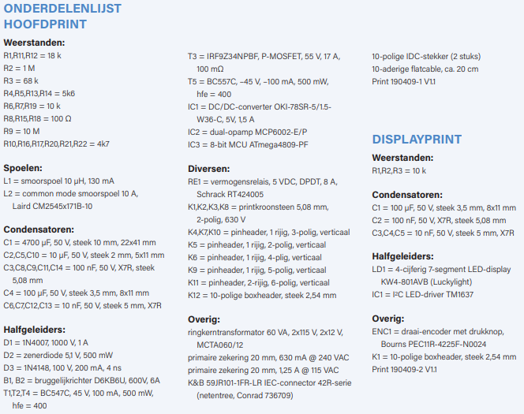

Figure 1

Note that not all components used in this project are exactly the same as the ones used in the Elektor magazine. SMD (surface mount device) components often   
replaced their through hole versions.

This was primarily done to minimalize the overall size of the PCB.

And since this personal version of the project didn’t use a dedicated PCB for the display, there was no need for a connection cable between the boards.

# Results

**Startup menu**

Before connecting the soldering station, press the button on the rotary encoder during power-on to access the startup menu. The menu allows for selecting the type of soldering iron, with three options available: C0 for the Hakko FX-8801, C1 for the JBC T245, and C2 for the Weller RT. To save the selection, hold the rotary encoder for ten seconds. The station will restart with the correct voltage and analog input for temperature measurement.

**Temperature adjustment**

During normal use, adjust the temperature of the soldering iron as necessary using the rotary encoder. After releasing the button, the new temperature setting is saved five seconds later. The display shows the actual temperature of the tip, and the left decimal point blinks during heating.

**Soldering**

Once the iron is hot, place the tip on the joint to be soldered and apply solder as needed. Adjust the temperature as necessary to achieve good solder joints.

**Power-off and storage**

When finished, the soldering station should be turned off and the iron should cool off before storing it. Proper storage of the iron will extend its lifespan and maintain its performance.

**Pictures of the (almost) finished product.**

Figure 2 is a picture of the soldering station.

Figure 2

The lines and imperfections of the housing are

the result of using a 3D-printer that isn’t setup

properly.

Figure 3 is a picture of the PCB, note that the encoder and display are mounted on the other side.

Figure 3

# Discussion

Throughout the design process, various challenges were encountered while working on the project. One of the main issues was related to using Altium Designer software. It was challenging to find all the necessary parts and their footprints in the available libraries. This led to delays and confusion during the project development.

Another challenge was related to a group purchase that was made for the project. Buying components in larger quantities is beneficial for minimalizing the price of the project. Most parts were purchased on Mouser.  
The group purchase resulted in further confusion as it was difficult to determine which specific components where ordered since there are many variants for certain components. This made it harder to verify if the right component was used while making the schematics in Altium Designer.

Due to these difficulties, the project was way more time-consuming than expected. Looking back at the process, there are several changes that could have been made to improve it. Firstly, it would be better if the student has all the required components before starting the design process. This could be done by purchasing the components beforehand, even before the start of the semester.  
Another reason was verifying components their availability in the Altium Designer libraries or on the internet before starting.  
Lots of components lacked the possibility to download their schematics, this was an inconvenience especially when seeing this late in the designing phase.

Secondly, it would be better to have a more detailed record of the components that were ordered during the group purchase. This would help in identifying the specific components since there are many varieties.  
Knowing the name of the exact component is really important for finding the right footprints.  
Footprints are a type of schematic that contains all the information in relation to the dimensions of the component.  
Many errors could have been avoided by having a spotless custom library with all the right schematics of the electronic components needed for the soldering station.

In conclusion, the design process faced several challenges, resulting in the project not working as intended. These challenges could have been addressed by taking some precautionary measures, such as purchasing components beforehand and maintaining a detailed record of components ordered during the group purchase.

# Reference list

1. Elektor magazine
2. All the documents provided by Patrick Hilven on how to make a PCB-board and a housing